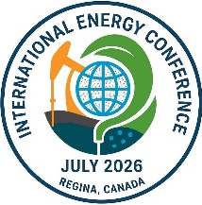 | IEC 2026 – Abstract Submission
1. Abstract Title:
2. Author Information
(1) Author Details
First Name | Last Name | Affiliation / Institution | Position / Title | Email Address
(2) Is the first author a student? ☐ Yes ☐ No
If the first author is a student, is he/she willing to participate in the “Energy Future” Student Competition? ☐ Yes ☐ No
3. Presentation and Submission Options (Please select ONLY one option)
☐ (1) Presentation Only
☐ (2) Presentation and Journal Submission via Conference
Proceedings Inclusion (If journal submission via conference is unsuccessful) ☐ Yes ☐ No
☐ (3) Presentation and Independent Journal Submission
4. Conference Symposia and Topics
(1) Main Symposium Category (Please select the primary symposium for your abstract)
---- Please Select ----
(2) Symposium Topic (Please fill ONLY the topic list corresponding to your selected main category)
---- Please Select ----

5. Abstract Main Information
(1) Title:
(2) Please summarize the objectives and scope of the study, the methodology used, the key results and observations, and the main conclusions or novel contributions of your work.
(Please enter your full abstract here, 300–500 words.)

